- . The long-term impacts of emerald ash borer on ash populations in forests near the epicenter of invasion
Abstract
Emerald ash borer (EAB) has been present in forests of southeast Michigan for more than 20 years, creating economic and ecological consequences. Ash (Fraxinus spp.) regeneration in the understory survived the initial EAB outbreak and may be growing to larger sizes which are now susceptible to EAB attack. Introduced natural enemies have been widely released for more than 15 years (Duan et al. 2023), which could help protect ash saplings as they continue to grow. The persistence or extirpation of ash trees will depend on interactions between regeneration and populations of EAB, natural enemies of EAB, competition with other plants, and site conditions. We surveyed for the occurrence and health of ash regeneration in 37 forested transects in the outskirts of Detroit, MI. These transects were classified based on their hydrology, and included xeric upland, mesic, and hydric swamp forest. We found that as of 2024-2025, ash remained present in 36 of the transects, but the size distribution and abundance of regeneration varied. Specifically, ash regeneration in mesic and xeric forest remained in the seedling and sapling sizes (mostly under 137 cm tall). Conversely, regeneration in hydric swamp forest reached the size of ash trees (2.5-10 cm diameter at breast height, DBH) which are susceptible to EAB attack. Symptoms of EAB are common on these growing trees, but many remain healthy, with 57% of ash larger than 5 cm DBH having healthy canopies. Furthermore, we recovered three species of introduced natural enemies, suggesting that parasitoids may be playing a role in regulating populations of EAB. We also completed a survey of all tree species in hydric forests, which indicated that black ash (Fraxinus nigra Marshall) regeneration tends to occur in stands containing tamarack (Larix laricina (Du Roi) K. Koch), and does not occur as often in stands with silver maple (Acer saccharinum L.). Our results suggest that ash in hydric swamps are closer to reaching the sizes required to produce seeds than ash in mesic or xeric forests. However, their success will depend on interactions between tree resistance to EAB, population fluctuations of EAB, and parasitoid natural enemies.

Introduction
Forests are increasingly impacted by anthropogenic stressors, including the establishment and spread of nonnative species (Lovett et al. 2006). Nonnative tree-feeding insects have been especially significant, causing economic and ecological impacts (Gandhi and Herms 2010, Van Driesche and Reardon 2016). These pests can undergo exponential population growth because top-down and bottom-up processes are reduced in the invaded range. Insects introduced to a new region can escape their specialist natural enemies which might otherwise control their populations (Roy et al. 2011, Duan et al. 2023). Furthermore, native tree species do not share a coevolutionary history with nonnative insects and may lack the necessary physical or chemical defenses (Villari et al. 2016, Mech et al. 2019). Release from these top-down and bottom-up controls can lead to rapid and widespread mortality of host trees, which has short- and long-term impacts on forest structure and function. In the short term, tree mortality forms canopy gaps that increase light availability and temperature and alter soil moisture on the forest floor (Perry and Herms 2019). Multiple size classes of trees can respond to the available resources, including canopy trees and/or advanced regeneration in the understory (Oliver and Larson 1996, Hoven et al. 2020). If the host tree species has surviving seedlings, saplings, or root sprouts, this regeneration may compete to reclaim the space. However, regeneration of the host tree species can be hindered by the continual presence of the nonnative insect (Olatinwo et al. 2021). Eventually, host tree species may be functionally eliminated from forests, or they may continue to be important components of the community (McCormick and Platt 1980). If they do survive, they may do so in a different size range, or only within certain forest types (Barnes 1976).
Emerald ash borer (EAB, Agrilus planipennis Fairmaire) is an introduced woodboring beetle (Coleoptera: Buprestidae) that has had substantial direct and indirect ecological impacts in forests (Klooster et al. 2018). First identified near Detroit, Michigan in 2002, EAB has since spread throughout the eastern United States, in parts of eastern Canada, and into Colorado and Oregon (Ward et al. 2020, Canadian Food Inspection Agency 2025, USDA–APHIS 2025). Extensive mortality of North American ash (Fraxinus spp.) has occurred in regions where EAB has become established. For example, mixed deciduous forests near the epicenter of the EAB invasion experienced more than 99% mortality of canopy ash by 2009 (Klooster et al. 2013). Ash trees with EAB larvae tunneling in their vascular system exhibit symptoms like bark splitting, epicormic sprouting, canopy foliage dieback, and death (Knight et al. 2014). Concurrent with the death of mature ash, viable seed production declined precipitously, which threatens to eliminate the ash from forests (Klooster et al. 2013). To attempt control of EAB populations, several biological control agents native to east Asia have been widely released in eastern North America. Three parasitoid wasp species have established and are impacting EAB populations (Duan et al. 2015, 2023, Aker et al. 2022, Quinn et al. 2023).
Although the majority of mature ash have died, ash seedlings and saplings that were too small to be colonized by EAB during the initial wave of mortality are abundant in many forest understories (Aubin et al. 2015, Ward et al. 2021). If this regeneration grows large enough to reproduce and generate viable seeds, then ash could remain a long-term component of eastern North American forests. However, EAB populations persist in post-outbreak forests, albeit at low densities (Duan et al. 2015). As ash saplings grow to larger sizes, they become susceptible, increasing the likelihood that persisting populations of EAB will kill them (Duan et al. 2017). Recent evidence suggests that the introduced parasitoids could provide enough EAB-population control to protect regenerating ash in post-outbreak forests (Duan et al. 2015, McCullough 2019). Tetrastichus planipennisi Yang (Hymenoptera: Eulophidae) parasitizes EAB larvae through the thinner bark of young ash trees (<12 cm in diameter) (Abell et al. 2012, Duan et al. 2023), while the longer ovipositor of Spathius galinae Belokobylskij (Hymenoptera: Braconidae) may allow it to parasitize EAB larvae within ash trees up to about 39 cm in diameter (Murphy et al. 2017). Meanwhile, the tiny Oobius agrili Zhang & Huang (Hymenoptera: Encyrtidae) parasitizes EAB eggs in bark crevices (Quinn et al. 2023). The long-term persistence of ash populations in natural forests of North America will depend on the dynamic interactions among the cohort of immature ash in the forest understory, competing plants, low-density EAB populations, and introduced parasitoids.
Species of ash currently grow in many forest types across North America, including different hydrological conditions (Wagner and Todd 2015). Long-term patterns of ash regeneration and persistence may vary among forest types due to local abiotic and biotic conditions. Ash is found in early-successional old-fields (Morris et al. 2023), mixed hardwood forests on slopes (Royo and Knight 2012), riparian areas along streams (Engelken et al. 2020), river floodplains (Siegert et al. 2021), swamps formed from glacial lake plains (Abella et al. 2019), and depressional areas fed by ground or surface water (Golet et al. 1993). These forests can be classified using a variety of abiotic characteristics, but hydrology is one of the most impactful because of its effect on tree survival and species composition (Megonigal et al. 1997, Niinemets and Valladares 2006). Based on hydrology, forest stands may be classified as xeric, mesic, or hydric. Ash species vary in their hydrological niches, with white ash (Fraxinus americana L.) preferring xeric or mesic sites, green ash (Fraxinus pennsylvanica Marsh) preferring mesic or hydric sites, and black ash (Fraxinus nigra Marsh) preferring hydric sites (Burns and Honkala 1990, Wagner and Todd 2015). Hydric, mesic, and xeric stands also vary in baseline levels of canopy openness, as well as in the size and shape of canopy gaps formed by EAB-induced ash mortality (Smith 2006, Klooster 2012). These differences in light availability, as well as abiotic stressors like flooding and drought, create different understory plant communities depending on hydrology (Engelken et al. 2020). Hydric forests are unique because ash species, particularly black ash, were often dominant. Black ash has adaptations that allow it to transpire even when the ground is flooded, which helps draw down the water table in seasonally flooded areas (Telander et al. 2015, Kolka et al. 2018). The importance of black ash in regulating abiotic conditions, coupled with black ash’s high susceptibility to EAB, make these ecosystems particularly important to study in the aftermath of EAB (Siegert et al. 2023).
Given the uncertain future of ash in eastern North American forests, it is important to understand the potential for ash survival and regeneration in invaded forests with low-density EAB populations and a history of biological control releases. We resurveyed long-term forest research sites established during the early stages of ash mortality near the epicenter of invasion to investigate the occurrence and health of ash populations more than two decades after the detection of EAB. Our first objective was to quantify the abundance and health of ash regeneration in hydric, mesic, and xeric forests. We predicted that newly germinated seedlings would be absent due to a lack of seed-producing ash trees, and that the incidence of signs and symptoms of EAB would increase with increasing ash tree diameter (Klooster et al. 2013, Duan et al. 2017, Ward et al. 2021) due to the continued presence of EAB in these forests (Duan et al. 2015). Furthermore, we predicted that occurrence of ash regeneration would depend on soil hydrology of the forest, due to the associations between hydrology and ash species, canopy gap size, abiotic stressors, and understory vegetation dynamics. Our second objective was to evaluate whether introduced parasitoid natural enemies of EAB could be recovered at our sites following a history of releases in the region. To further explore the responses in hydric forests, our third objective was to characterize tree species composition in these post-outbreak forests.

Methods
Study area
This study was conducted in 37 transects previously established in 2004-2008 in mixed hardwood stands on public land within the Upper Huron River Watershed in southeast Michigan (Table A.1) (Smith 2006; Klooster et al. 2014; Smith et al. 2015). Forest transects were established in the Huron-Clinton Metroparks (Indian Springs, Kensington, and Hudson Mills) and Michigan State Recreation Areas (Pontiac, Highland, Proud Lake, and Island Lake) (Fig. 1.1A). Transects were initially characterized by the dominant ash species present (F. americana, F. pennsylvanica, or F. nigra) and hydrologic conditions (xeric, mesic, or hydric soils) (Smith 2006). Transects in well-drained upland forests with white ash were classified as xeric (n=19). Transects with moderately well-drained soils with mostly green ash were classified as mesic (n=8). Transects in floodplains with water-saturated soils, standing water for part of the year, and black ash and/or green ash were classified as hydric (n=10). Transects were located 24-45 km from the epicenter of EAB invasion in Canton, Michigan (Siegert et al. 2014) and have a long history of EAB. EAB was present in most transects in 2004-2005, and >99% of ash above 2.5 cm diameter were killed by 2009 (Klooster et al. 2013). Aside from hydrology, transects also varied in total tree basal area and density, tree species diversity, and ash basal area and density (Smith et al. 2015). Other than ash, common tree genera included maple (Acer), oak (Quercus), cherry (Prunus), hickory (Carya), tuliptree (Liriodendron), aspen and cottonwood (Populus), elm (Ulmus), basswood (Tilia), hophornbeam (Ostrya), and musclewood (Carpinus) (Smith et al. 2015). The region is a post-glaciated landscape, with moraines forming the upland areas. In some cases, precipitation seeps through the moraines and fills lowland areas with mineral rich water (Kost and O’Connor 2003).
Within each transect, three replicate 18 m radius circular plots (0.1 ha) were previously established with a multiscale sampling design to facilitate vegetation surveys (Fig. 1.1B). Each plot was composed of an 18 m radius main plot, a nested 8 m radius subplot, and four 4.06 m² microplots, one in each cardinal direction. When established in 2004-2008, all plots contained at least two mature ash trees. Additional details on plot establishment and characterization are provided in Smith (2006). In the main plot, subplot, and microplots, we resurveyed ash trees, saplings, and seedlings during the growing seasons in 2024 and 2025.

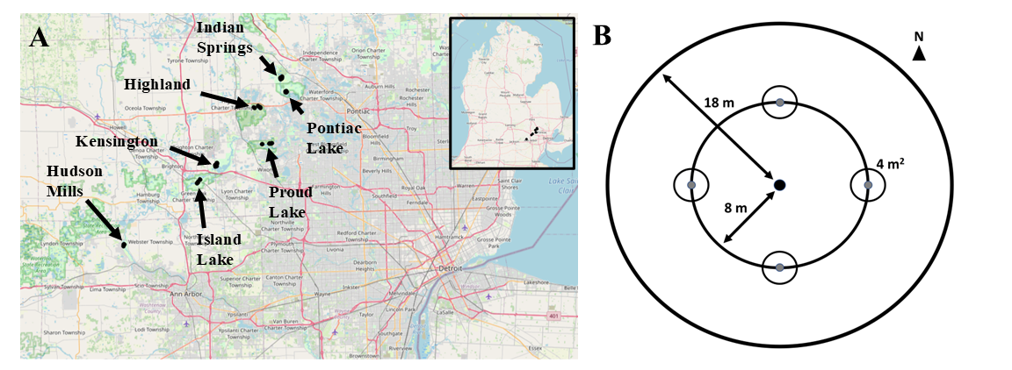
Figure 1.1. Map of southeastern Michigan showing the locations of the seven Huron-Clinton Metroparks (Indian Springs, Kensington, and Hudson Mills) and Michigan State Recreation Areas (Pontiac, Highland, Proud Lake, and Island Lake) where forest stands were surveyed (A). Plot design, showing the 18 m radius main plot, the 8 m radius nested subplot, and the four 4 m² area microplots located in cardinal directions (B). Forest transects were comprised of three replicate plots.

Ash abundance and health
To assess the abundance and health of ash, canopy ash trees (≥10 cm diameter at breast height, DBH) were surveyed within the entire 18 m radius main plots, understory ash trees (2.5-10 cm DBH) and living ash saplings (≥137 cm in height but <2.5 cm DBH) were surveyed within the central 8 m radius subplots, and living ash seedlings (<137 cm in height) were surveyed within the 4 m² microplots. All seedlings were checked for the presence of cotyledons which would indicate they were newly germinated (Klooster et al. 2013). Ash seedlings were counted in two height categories, <25 cm and >25 cm, and the percentage cover of ash seedlings in microplots was estimated (Klooster et al. 2013).
When present, canopy and understory ash (>2.5 cm DBH) were assessed individually for DBH, species, and health. All DBH measurements were taken at a height of 137 cm (Ward et al. 2021). Due to difficulties in distinguishing green and white ash, species designations were grouped into three categories: 1) black ash; 2) all other species of ash, including white ash, green ash, and potentially pumpkin ash (Fraxinus profunda Bush); and 3) unknown ash species because the tree was dead. After recording ash species, the tree was checked for signs and symptoms of EAB, including the presence of D-shaped emergence holes, woodpecker predation marks, bark splitting, epicormic sprouts, and basal sprouts. Furthermore, the canopy condition was rated using a 1 to 5 scale, where 1 represented a healthy canopy, 5 represented complete defoliation of the canopy (possibly still with living epicormic sprouts), and 2-4 represented increasing stages of decline (Smith 2006, Klooster et al. 2013, Knight et al. 2014). For statistical analyses, we simplified the canopy condition variable into two binary variables, ash tree decline and ash tree death. Ash tree decline was coded as 1 if the canopy condition showed any signs of decline (i.e. if canopy condition ≥ 2) and 0 if the canopy condition = 1. Ash tree death was coded as 1 if canopy condition = 5, and 0 otherwise (adapted from Hoven et al. 2020).

EAB trapping
In 2024, we used purple-prism traps and multi-funnel traps to assess EAB presence at six of the seven study parks (all except Hudson Mills Metropark, Table A.2). Two purple-prism traps were installed at each park, for a total of 12 prism traps. Additionally, three multi-funnel (Lindgren) traps were installed at one park, Pontiac Lake Recreation Area. Traps were hung on or near the biggest ash trees that could be found during preliminary site visits. Traps were installed between May 29 and June 5, 2024 (627-734 GDD, base 50 °F, single sine method), and removed between July 23 and July 25, 2024 (1733-1770 GDD) (Oregon State University 2022). Purple prism traps used standard purple (“Coroplast purple”) colored board coated with glue (TAD Insect Trap Coating, Great Lakes IPM). Multi-funnel traps were filled with a 20% propylene glycol solution. Traps were hung at varying heights on or near ash of varying size classes, depending on what was found at a park (Table A.2). All traps were baited with Manuka oil (Scentry Biologicals Inc., Billings, MT) and a fresh lure was installed halfway through the summer, between June 25 and July 3 (1146-1283 GDD). All buprestid beetles were removed from purple prism traps monthly, and from multi-funnel traps weekly, and EAB were counted and sexed (Parsons 2008).

Parasitoid sampling
In 2024, yellow pan traps were used to determine whether the introduced biological control agents had established in the area. Traps were installed at Pontiac Lake Recreation Area at plot 53 due to a high abundance of ash saplings and seedlings in the understory. Yellow pan traps were composed of two nested yellow plastic bowls attached to the trunk of an ash tree and filled with 20% propylene glycol (Duda Energy LLC, Decatur AL) solution and a drop of unscented dish soap (USDA–APHIS/ARS/FS 2021). The USDA design was modified by using polypropylene webbing straps instead of nails to attach to the tree (Figure A.2). On June 4, 2024, 15 traps were attached at a height of 5-6 feet to green or white ash trees (3.2-9.6 cm DBH) (Table A.3). Traps were collected weekly until August 8, 2024, by pouring the collection liquid through a fine mesh paint filter (TCP Global, San Diego CA, listed as 190 μm, actually ~300 μm = 0.3 mm) and rinsing with distilled water. Since the smallest introduced parasitoid, Oobius agrili, averages 0.95 mm long (Zhang et al. 2005), a 0.3 mm mesh size was sufficient to collect all three parasitoid species. Paint filters were cooled on ice within 30 minutes and frozen within 24 hours (USDA–APHIS/ARS/FS 2021). To sort trap contents, a paint filter was placed into a petri dish and 70% isopropanol in distilled water was added. The introduced biological control agents of EAB were identified using USDA guidelines (USDA–APHIS/ARS/FS 2021) and determinations were verified (Toby Petrice, personal communication).

Vegetation survey in hydric transects
In 2025, non-ash canopy trees (≥12.5 cm DBH) and understory trees (2.5-12.5 cm DBH) were characterized in the 18 m radius main plot and the 8 m radius subplot, respectively, to investigate plant composition in hydric forests following the loss of ash. All trees within hydric plots were identified to species if possible and rated as living or dead (dead trees could still have living epicormic sprouts). Trees that divided into two or more branches below breast height (137 cm) were considered as the same tree and were counted if their sum of diameters was greater than the threshold (i.e., 12.5 cm for the main plot or 2.5 cm for the subplot). Stems were considered as separate trees if they remained separate down to ground level, even if they likely connected belowground (Abella et al. 2019).
In addition to tree surveys, percentage cover was estimated for woody shrubs, graminoids (grasses, cattails, and sedges), skunk cabbage (Symplocarpus foetidus (L.) Salisb.), ferns, and standing water. The percentage cover of the shrubs poison sumac (Toxicodendron vernix (L.) Kuntze), spicebush (Lindera benzoin L.), winterberry (Ilex verticillata (L.) A.Gray), and glossy buckthorn (Frangula alnus Mill.) were scored individually. Percentage cover was visually estimated for each of these categories by standing at 8 m in the NE, SE, SW, and NW quadrants of the 18 m radius plot. The four estimates for each cover type were averaged for a plot-level estimate.

Statistical analysis
All analyses were conducted in R version 4.4.1. All code and development history that support these findings can be found in the GitHub repository: https://github.com/KPerryLab/EAB_Michigan_2024_2025.
For the first objective, the unit of replication was the transect, and counts of ash canopy and understory trees, ash saplings, and ash seedlings were each summed across the three plots in a transect. Densities were calculated in units of stems per hectare. For canopy and understory trees, density of standing dead trees (canopy condition = 5) was calculated separately from density of living trees (canopy condition < 5). Basal area was calculated for living canopy and understory trees using the formula Σ(π*(d/2)²), where d is the DBH of each individual tree stem (Hoven et al. 2020). Multiple stems of a single tree were considered individually for basal area calculations but were considered as the same tree for tree counts.
To test for differences in ash populations among hydrological classes, we used generalized linear mixed-effects models (GLMMs). The response variables were number of short ash seedlings (count), number of tall ash seedlings (count), mean percentage cover of ash seedlings (continuous), number of ash saplings (count), and number of living understory ash trees (count). Due to a low number of observations, the number of canopy ash (≥10 cm DBH) was not tested statistically. A separate model was created for each response variable. Hydrological class (xeric, mesic, or hydric) was treated as the fixed effect predictor and park was included as a random intercept. For each count response variable, a Poisson GLMM with a log link function was implemented using the package ‘lme4’ (Bates et al. 2015) in R (R Core Team 2024). The package ‘DHARMa’ was used to determine if the observed data were adequately modelled by the GLMM (Hartig 2024). If residuals were determined to be overdispersed, a negative binomial error structure was implemented using the ‘lme4’ (Bates et al. 2015) and ‘MASS’ (Venables et al. 2002) packages in R. The residuals of the negative binomial GLMM were similarly examined to verify model fit. Furthermore, the Akaike Information Criterion (AIC) was compared between the Poisson and negative binomial models to verify improvement in fit. The models for number of saplings and number of understory trees were singular fits, so the random intercept term for park was dropped. For the mean percentage cover of ash seedlings, a linear mixed effects model with a Gaussian error structure was used. The mean percentage cover was transformed using the function f(x)=ln(x+1) to satisfy the assumption of homogeneity of variances. For all models, the ‘Anova’ function in the R package ‘car’ (Fox and Weisberg 2019) was used to test for overall differences among hydrological classes, and Tukey contrasts were calculated using the R package ‘emmeans’ (Lenth 2024).
To test the hypothesis that ash tree diameter would be positively correlated with signs and symptoms of EAB attack, generalized linear mixed-effects models with binomial error structure and logit link functions were implemented using the package ‘lme4’ (Bates et al. 2015). The binary (y/n) response variables tested were woodpecker predation marks, bark splitting, epicormic sprouts, basal sprouts, ash tree decline, and ash tree death. The fixed effect predictor variable was tree DBH. Plot was included as a random intercept to account for non-independence of trees in a plot. A Z-test was used to test the null hypothesis of no relationship between DBH and the EAB symptom. For our analysis, understory and overstory ash trees were pooled, and any tree was excluded if it belonged to a plot where less than 10 trees were found, which yielded a sample size of 283 trees. This was so that we could account for differences in frequency of EAB symptoms based on site conditions (which might vary by plot). A cutoff of 5 trees in a plot was also tested and did not change the direction or significance of the results. To assess the accuracy of the models, trees were binned into increments of 1 cm diameter, and the proportion of trees in each bin showing the EAB symptom was calculated. A model was judged as a good fit if the model trendline passed through the proportions for each bin.
To understand differences in plant communities in hydric forests, we characterized tree species composition in each plot separately, rather than combining plots into transects. This was because some transects had variation between plots in tree species composition. Tree species composition was visually assessed using nonmetric multidimensional scaling (NMDS) with the function ‘metaMDS’ in the ‘vegan’ package (Oksanen et al. 2024). The Bray-Curtis dissimilarity between each of the 30 plots was calculated using the basal area (≥ 2.5 cm DBH) of each tree species. Tree species were included in the analysis if they had ≥ 10 trees observed. The white oaks (Quercus alba, Q. bicolor, and Q. macrocarpa), red oaks (Q. rubra and Q. palustris), poplars (Populus deltoides and P. grandidentata), and elms (Ulmus sp.) were not identified to species level for the NMDS analysis.

Results
In our survey of the 37 transects, we found 2981 ash seedlings, 1037 ash saplings, 276 living and 54 dead standing understory ash trees, and 7 living and 2 dead standing canopy (>10 cm DBH) ash trees. The basal area of living ash trees (≥ 2.5 cm DBH) at the transect level ranged between 0 and 2.60 m²/ha but averaged only 0.24 m²/ha. Ash seedlings were observed in 36 of the transects, but none had cotyledons. Only four ash trees were found producing seeds in the 18 m radius plots, including a 2.9 cm DBH green ash and three black ash trees ranging from 6.6 to 11.5 cm DBH. EAB adults were trapped at most parks, but in low densities (Fig. A.3). Three introduced biological control agents were recovered, Spathius galinae (3 individuals collected), Oobius agrili (2 individuals), and Tetrastichus planipennisi (2 individuals), but in low abundance. Parasitoids introduced for EAB biocontrol comprised 0.46% (7/1537) of the Hymenoptera caught in pan traps.
Abundance of ash among forest types
The average density of ash seedlings ranged from 0-54,000 stems/ha (0-5.4 stems/m²), with an average of 16,500 stems/ha (1.7 stems/m²). Of these ash seedlings, approximately half were in the shorter size class (0-25 cm tall) while the other half were in the taller size class (25-137 cm tall) (Table 1.1). Percentage cover of ash seedlings averaged 10.7% of the forest floor across all 37 transects. Ash seedling densities and percentage cover were lowest in hydric transects, relative to mesic and xeric transects (Fig. 1.2A; short seedlings model: χ²=12.63, 2 df, p=0.002; tall seedlings model: χ²=19.12, p<0.001, percentage cover model: χ²=17.72, p<0.001). The density of ash saplings (>137 cm tall and <2.5 cm DBH) was similar among hydrological classes (χ²=0.26, p=0.88) (Fig. 1.2B). A total of 330 understory (2.5-10 cm DBH) ash trees were found, and of these, 276 were living (canopy condition 1-4), while 54 were dead and standing. Hydric transects had more understory ash trees than xeric transects and marginally more understory ash trees than mesic transects (Fig. 1.2C; χ²=14.63, p=0.001). Of the 330 understory ash trees, 131 were identified as being green, white, or pumpkin ash, while 178 were identified as black ash, and 21 were unidentified Fraxinus (Figure A.1). Only 9 canopy ash trees (≥ 10 cm DBH) were found across all plots, of which 7 trees were living. Living canopy ash trees within the plots ranged in diameter from 10.3-12.4 cm DBH.

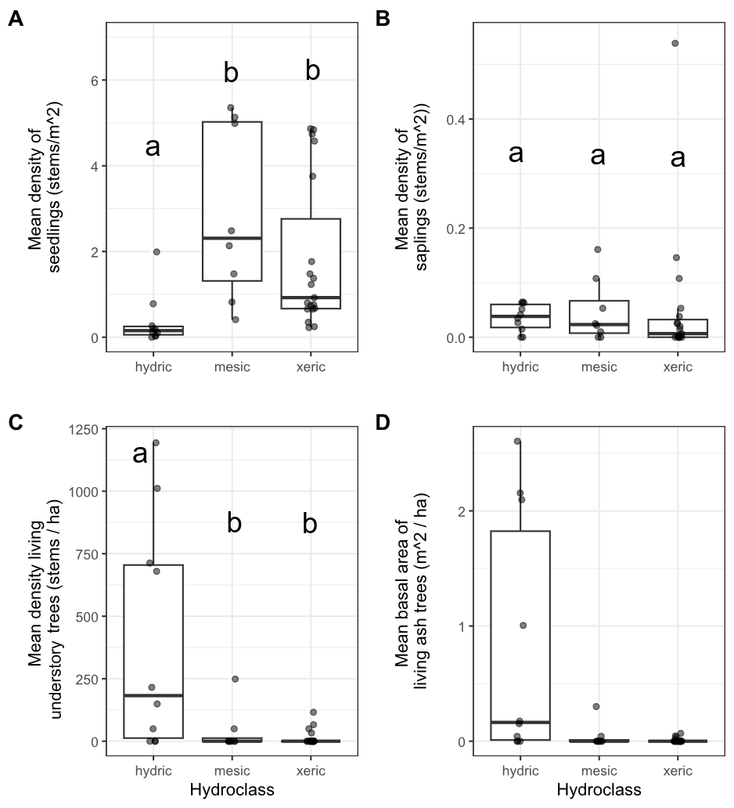
Figure 1.2. Ash occurrence in 37 transects in the Upper Huron River Watershed in southeast Michigan. The x-axis represents the soil hydrological class of the transect. Each data point represents a transect. Lowercase letters above bars indicate statistically significant differences at α=0.05. A) Mean density of ash seedlings (all ash with height < 1.37 m; short and tall seedling categories were combined for the graph), B) mean density of ash saplings (height ≥ 1.37 m and DBH < 2.5 cm), C) mean density of living understory ash trees (2.5 cm ≤ DBH < 10 cm), D) mean basal area of all living ash trees (DBH ≥ 2.5 cm). The basal area of living ash trees was not statistically investigated due to low occurrence.

Table 1.1. Density (± standard error) of living ash (Fraxinus spp.) regeneration in hydric (n=10), mesic (n=8), and xeric (n=19) transects in the Upper Huron River Watershed in southeast Michigan, USA. Data were collected during the growing season in 2024-2025. Table columns are size class (including short seedlings, tall seedlings, saplings, understory trees, and canopy trees), hydrology class (including hydric, mesic, xeric, and combined), and ash per hectare.

Size class | Hydrology class | Ash ha⁻¹
Short seedlings (<25 cm tall) | Hydric | 1,334 ± 952
 | Mesic | 15,420 ± 4,920
 | Xeric | 9,895 ± 2,458
 | Combined | 8,776 ± 1,824
Tall seedlings (25-137 cm tall) | Hydric | 2,381 ± 994
 | Mesic | 13,085 ± 2,563
 | Xeric | 8,351 ± 1,625
 | Combined | 7,761 ± 1,189
Saplings (>137 cm tall and <2.5 cm DBH) | Hydric | 360 ± 79
 | Mesic | 472 ± 205
 | Xeric | 517 ± 286
 | Combined | 465 ± 152
Understory trees (2.5 – 10 cm DBH) | Hydric | 401 ± 145
 | Mesic | 37 ± 31
 | Xeric | 14 ± 7
 | Combined | 124 ± 48
Canopy trees (>10 cm DBH) | Hydric | 2 ± 2
 | Mesic | 0
 | Xeric | 0
 | Combined | 0

Signs and symptoms of EAB
Of the symptoms of EAB, bark splitting was the most common and was found on 193 (57%) ash trees (DBH ≥ 2.5 cm). Epicormic sprouts were found on 122 (36%) ash trees. Basal sprouts were found on 54 (16%) ash trees, while woodpecker predation marks were found on 46 (14%) ash trees. Out of a total of 338 trees, 229 (68%) were classified as canopy condition 1, 33 (10%) had canopy condition 2, 13 (4%) had canopy condition 3, 7 (2%) had canopy condition 4, and 55 (16%) had canopy condition 5. The D-shaped emergence holes from EAB were observed rarely, with only 8 trees (2%) recorded with visible exit holes.
The presence of woodpecker predation marks was positively correlated with tree diameter (DBH), with a 1 cm increase in DBH increasing the odds of woodpecker marks by a factor of 1.24 (Z=2.46, p=0.013) (Fig. 1.3A). Similarly, presence of epicormic sprouts was positively correlated with DBH, with a 1 cm increase in DBH increasing the odds of epicormic sprouts by a factor of 1.31 (Z=3.49, p<0.001) (Figure 1.3C). The presence of canopy decline was positively correlated with DBH, such that a 1 cm increase in DBH increased the odds of canopy decline by a factor of 1.22 (Z=2.89, p=0.004) (Figure 1.3F). Even though canopy decline was positively correlated with DBH, 57% of ash larger than 5 cm DBH had healthy canopies (i.e., canopy condition 1). No relationships were observed between DBH and bark splitting (Z=1.64, p=0.102), presence of basal sprouts (Z=1.16, p=0.245), and tree death (Z=0.21, p=0.831) (Figure 1.3B, D, and E).

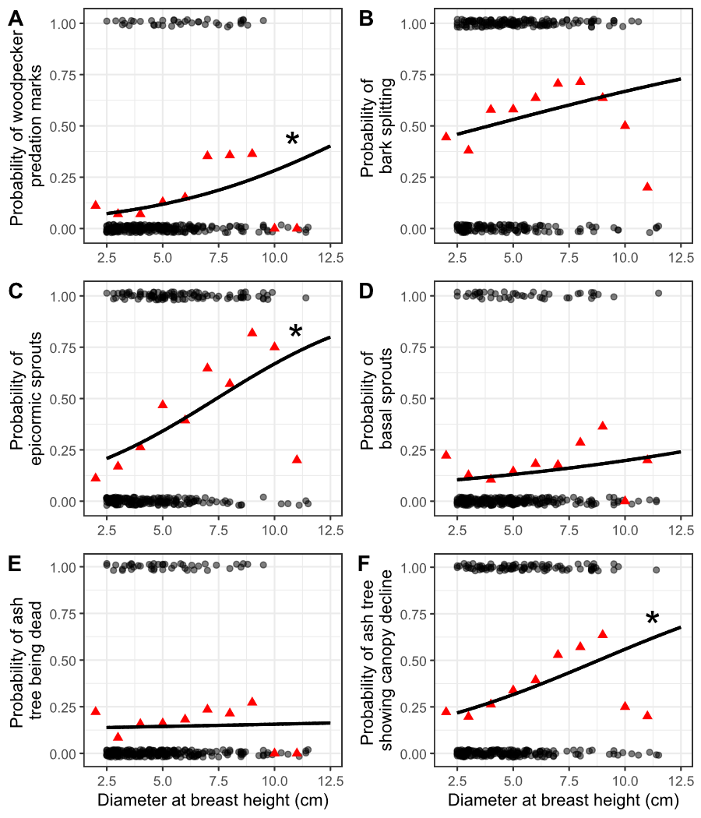
Figure 1.3. The presence or absence of symptoms of EAB plotted against tree diameter at breast height (DBH) for 283 ash trees. Trees were included in the analysis if they belonged to a forest plot containing at least 10 trees. Grey circles are individual trees, which are plotted as y=1 for presence or y=0 for absence (points were vertically jittered slightly). Black line shows the overall fitted model, disregarding each specific random intercept for each plot. See Figure A.4 for plots including each random intercept. Asterisk next to the lines for woodpecker predation marks, epicormic sprouts, and canopy decline indicate a slope significantly different from zero. Red triangles show the proportion of trees that have the symptom within a DBH bin. For E, tree death is defined as having a canopy condition of 5. For F, canopy decline is defined as having a canopy condition between 2-5 (minor to complete defoliation).
Plant communities in hydric stands
We identified 810 living canopy trees comprising 18 genera across the 10 hydric transects (Table 1.2). The most common species in the canopy (≥ 12.5 cm DBH) was silver maple (Acer saccharinum L.), followed by elm (Ulmus sp.), and basswood (Tilia americana L.). In the understory (2.5 ≤ DBH < 12.5 cm), 638 living trees were found, of which the most common species were musclewood (Carpinus caroliniana Walter), black ash (Fraxinus nigra), and green ash (Fraxinus pennsylvanica, possibly with some F. americana and F. profunda). The basal area of living trees in the canopy and understory averaged 21.1 m²/ha and 2.8 m²/ha, respectively, not counting shrub species. Of the ground-level cover types estimated in hydric plots, graminoids and skunk cabbage had the highest percentage cover (Table 1.3). The invasive shrubs glossy buckthorn (Frangula alnus Miller) and autumn olive (Elaeagnus umbellata Thunb.) were present, but with lower percentage cover than the native shrubs spicebush and winterberry. The NMDS ordination (Fig. 1.5) indicated a grouping of sample plots with high basal area of silver maple on the left side of the graph. Meanwhile, the upper center of the graph contained plots with species such as sugar maple (Acer saccharum Marshall). On the lower right side of the graph are plots with high basal area of yellow birch (Betula alleghaniensis Britt.) and/or tamarack (Larix laricina (Du Roi) K. Koch). The plots with high basal area of green ash tended to be in the forests with silver maple, whereas the plots with high basal area of black ash tended to be in forests with tamarack and/or yellow birch, although black and green ash also co-occurred in some plots.

Table 1.2. Relative density (%) and relative dominance (%) of canopy (≥12.5 cm DBH) and understory (2.5-12.5 cm DBH) tree genera found in the 10 hydric transects (30 plots) in 2024-2025. Only living trees were counted. A total of 810 living canopy trees were counted in the main plots and 638 living understory trees were counted in the subplots. Shrub species were not counted. The first column lists the genus of tree.
 | Relative density, % |  | Relative dominance, %
Genus | Understory | Canopy | Understory | Canopy
Acer | 10.5 | 42.3 | 18.7 | 63.5
Betula | 0.3 | 3.8 | 0.7 | 2.3
Carpinus | 19.5 | 2.7 | 12.1 | 0.3
Carya | 0.5 | 0.6 | 0.4 | 0.4
Cornus | 0.5 | 0 | 0.2 | 0
Fagus | 0.3 | 0.5 | 0.6 | 0.7
Frangula | 7.5 | 0.1 | 3.7 | 0
Fraxinus | 38.1 | 0 | 28.8 | 0
Juniperus | 0 | 0.1 | 0 | 0
Larix | 0.9 | 5.8 | 0.8 | 2.3
Ostrya | 0.9 | 0.4 | 0.7 | 0.1
Populus | 0 | 1.2 | 0 | 4.6
Prunus | 0.3 | 0.5 | 0.3 | 0.4
Quercus | 3.3 | 10 | 3.3 | 12.8
Rhamnus | 0.2 | 0.1 | 0 | 0
Tilia | 3.3 | 15.1 | 4.5 | 7
Ulmus | 13.3 | 16.2 | 24.7 | 5.5
Viburnum | 0.5 | 0.1 | 0.5 | 0

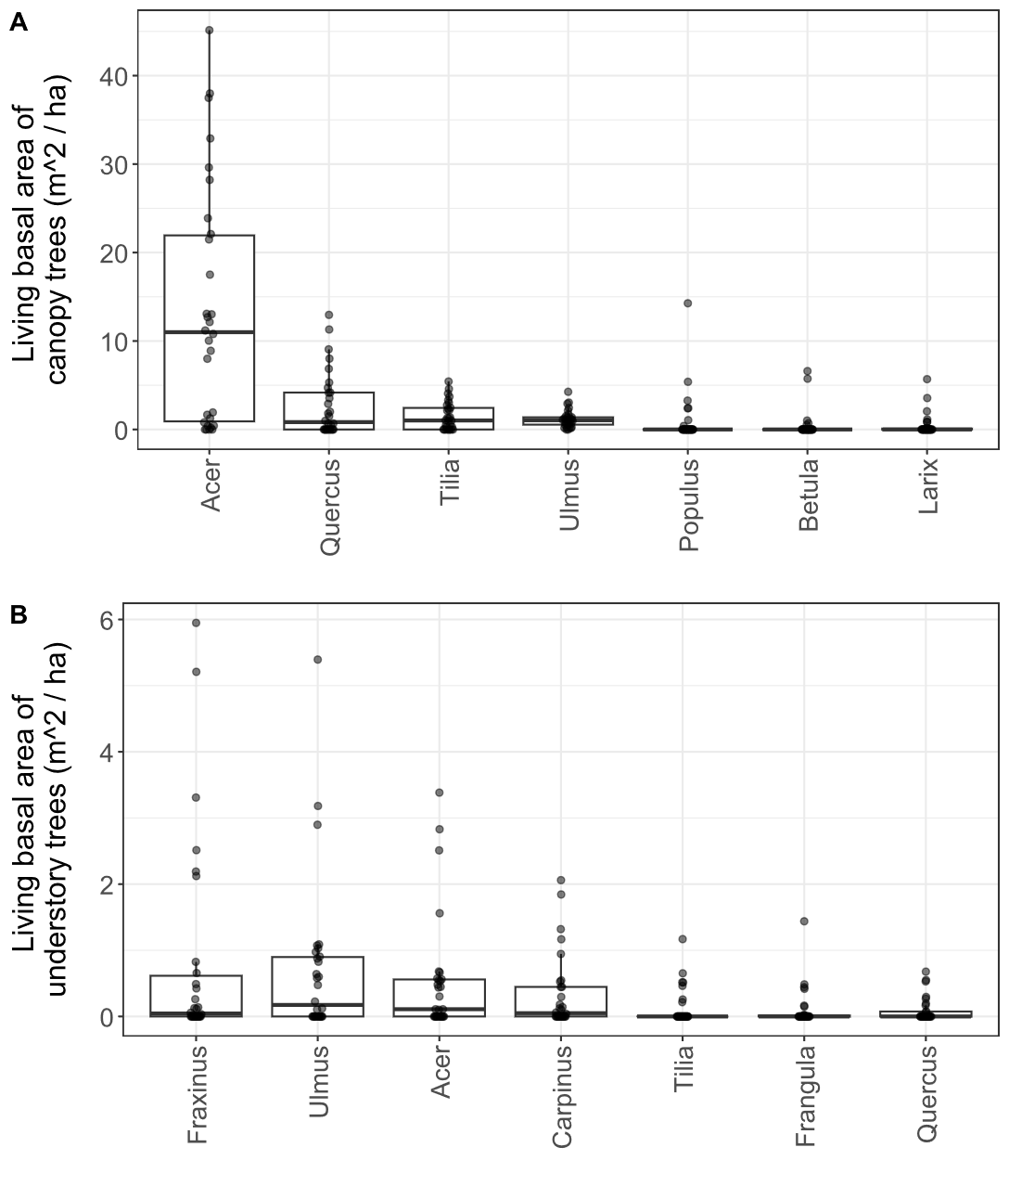

Figure 1.4. Basal area of living trees in the 30 hydric plots surveyed in 2025. Each dot represents a single plot. A) Canopy trees (≥ 12.5 cm DBH); B) understory trees (2.5-12.5 cm DBH). Tree genera were only included in the graph if their mean basal area was in the top seven. Note the difference in y-axis scale between the two graphs. Boxplot boundaries represent the 25th and 75th percentiles, while center line within the box is the median. Genera were arranged in the order of decreasing mean basal area.
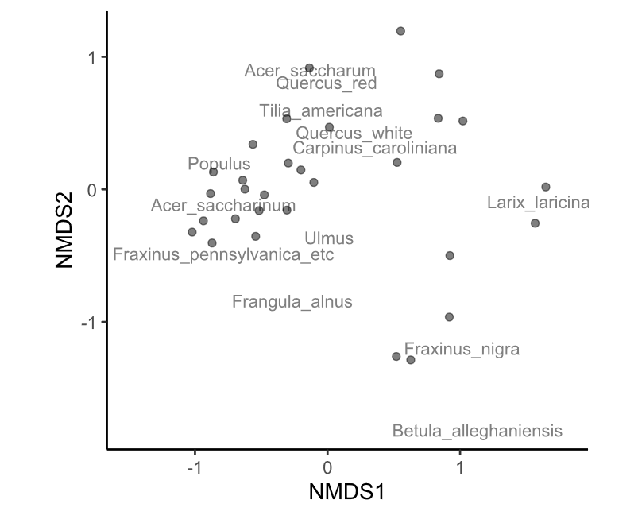
Figure 1.5. Nonmetric multidimensional scaling (NMDS) of the tree species composition among the 30 hydric plots visited in 2025. Each point is a plot. Data used to generate the NMDS was the basal area per hectare of each tree species, counting all trees ≥ 2.5 cm DBH. The final stress value was 0.149. Species were pooled within each of the red oak group (Quercus section Lobatae), the white oak group (Quercus section Quercus), Ulmus, and Populus for the analysis.

Table 1.3. Average percentage cover (± SE) of understory cover types in the 30 hydric plots surveyed in 2025. Standard errors were calculated using n=30. The columns are cover type, scientific name, and mean percentage cover ± standard error.

Cover type | Scientific name | Mean percentage cover (%) ± SE
Water |  | 9.8 | ± | 2.6
Graminoids | Poales | 52.7 | ± | 5.0
Skunk cabbage | Symplocarpus foetidus | 37.6 | ± | 5.0
Ferns |  | 16.5 | ± | 2.9
Spicebush | Lindera benzoin | 19.2 | ± | 4.4
Winterberry | Ilex verticillata | 5.7 | ± | 1.9
Glossy buckthorn | Frangula alnus | 3.6 | ± | 1.2
Poison sumac | Toxicodendron vernix | 2.1 | ± | 0.9
Other woody shrubs | Elaeagnus umbellata, Cornus spp., Rosa spp., Vaccinium spp., Corylus spp., etc. | 5.0 | ± | 0.8

Discussion
Over two decades since EAB was first detected in North America, we characterized ash survival and regeneration in forests that have experienced the longest history of EAB impacts. We found that ash regeneration was still present in these post-outbreak forests, although EAB continues to impact populations of ash. Ash regeneration remained at the seedling or sapling stages in mesic and xeric forests, but in hydric forests, ash regeneration consisted of trees in size classes susceptible to EAB. Parasitoids introduced to control EAB populations have established in the region, and we recovered three species, albeit in low numbers.
Stages of ash regeneration varied based on forest soil hydrology. In dry xeric and riparian mesic forests, ash seedlings were a prominent component of the understory layer, but ash trees >2.5 cm DBH were mostly absent. In hydric swamp forests, we found low numbers of seedlings, but higher densities of ash in the 2.5-10 cm DBH range. This suggests a difference in growth rate and/or regeneration stage, whereby ash regeneration tended to be more advanced in hydric forests. In our study locations, the hydric transects previously had a higher density of ash in the canopy than mesic or xeric transects, which may have resulted in larger canopy gaps following widespread ash mortality (Klooster 2012). Furthermore, overall canopy tree cover was lower in hydric forests than mesic or xeric forests even before significant ash loss (Smith 2006, Klooster 2012). Multi-tree gaps and high light availability likely allowed surviving ash regeneration to grow quickly as EAB populations declined following a reduction in host material in the landscape. Furthermore, black and green ash, which are highly tolerant of flooding, likely had an advantage in hydric forests over other co-occurring plant species, such as C. caroliniana, which are less flood tolerant (Table A.4) (Niinemets and Valladares 2006). In contrast, mesic and xeric forests may have developed mostly single-tree gaps from isolated ash canopy trees, allowing neighboring non-ash canopy trees to fill the gaps before saplings could grow substantially. In fact, saplings underneath mature canopy trees may require more than one tree-fall event in order to reach the canopy, due to the rapid canopy expansion of neighboring mature trees (Runkle and Yetter 1987). Other studies of forests after EAB invasion have similarly found rapid growth of canopy trees, such as sugar maples, to fill gaps left by ash mortality (Costilow et al. 2017, Hoven et al. 2020).
Although ash seedlings were abundant in these post-outbreak forests, almost none had cotyledons. I did, however, observe two individual ash seedlings, just outside a microplot, which had cotyledons (A. Tayal, personal observation). Thus, the vast majority of ash seedlings present are not newly germinated, but rather have established in previous years. The most plausible explanation is that ash seedlings are simply persisting from before 2008, when new germination from the seed bank ceased. While mortality and recruitment to larger size classes appear to have decreased ash seedling densities since 2010 (Klooster et al. 2013), a sizeable number (~16,500 seedlings ha⁻¹ for those under 137 cm tall) remain in these long-term monitoring plots. While the density of surviving seedlings is higher than observed in most other studies, it corroborates other findings that ash seedlings can persist for long time periods in forest understories (Engelken et al. 2020, Siegert et al. 2021, Morris et al. 2023). In particular, ash seedlings seem more capable of long-term persistence in mesic and xeric forests, whereas in hydric forests competition with graminoids and seasonal flooding can limit seedling abundances (Engelken et al. 2020, Abella et al. 2024). Importantly, our study found isolated examples of seed-producing ash trees rather than widespread seed production, likely indicating that the seedbank is not yet being replenished. This stands in contrast to some studies in which seed production continued even after EAB invasion (Kashian 2016, Robinett and McCullough 2019, Morris et al. 2023). It is possible that site conditions influenced the number of ash trees that survived the initial wave of EAB invasion, and thus the number of seed-producing trees available to replenish the seedbank (Knight et al. 2013, Kashian 2016).
We found that ash tree regeneration continues to be damaged and killed by EAB, but some trees are surviving well into the susceptible size range. We found that symptoms of EAB including the incidence of canopy decline, woodpecker predation marks, and epicormic sprouts all increased with increasing tree diameter. However, bark splits, basal sprouts, and tree death did not show any significant relationship with ash tree diameter. In particular, the distribution of bark splits across a range of ash diameters suggests that even some 2.5 cm DBH ash are being affected by EAB oviposition. Ash larger than 4 cm DBH may be more suitable for larval development, but female EAB still oviposit on stems as small as 2 cm DBH (Timms et al. 2006, Aubin et al. 2015). Even though EAB symptoms were common, we still found sizeable numbers of ash trees with healthy canopies in the 2.5-10 cm DBH range. This contrasts with patterns observed in 2009, when almost no ash >2.5 cm DBH were living (Klooster et al. 2013). Thus, ash trees continue to grow, although they have not yet attained sizes larger than 12.5 cm DBH in our study plots.
We found that canopy tree species composition varied in hydric swamp forests where EAB has been present for more than 15 years. Black ash provide ecological and cultural services in northern wet forests, including habitat for insects and birds, as well as raw materials for basket weaving by Tribal Nations (Gandhi et al. 2014, Wagner and Todd 2015, Youngquist et al. 2017, Bolen 2020). Because ash is a dominant tree in swamp forests of the northern US and Canada, ash mortality caused by EAB is currently having substantial impacts in these systems (Golet et al. 1993, Kolka et al. 2018, Siegert et al. 2023). We investigated tree composition in hydric forests to determine which species thrived after canopy ash mortality, and found that silver maple was abundant, especially in the canopy. This species thrives in alluvial soils and is highly tolerant of seasonal flooding (Table A.4) (Burns and Honkala 1990, Niinemets and Valladares 2006, Bolton et al. 2018). However, not all plant communities were dominated by silver maple but instead contained tamarack and sometimes yellow birch. Tamarack and yellow birch are typical of cooler, northern forests, whereas silver maple is commonly found further south of our study sites (Barnes 1976, Braun 1989, Burns and Honkala 1990, Kost and O’Connor 2003, Kartesz 2015). Regeneration of green ash primarily occurred alongside silver maple, whereas black ash regeneration was commonly associated with tamarack or yellow birch, although the two ash species were sometimes found in the same stands. These observed associations between tree species can inform restoration plantings in forests impacted by EAB, especially if land managers seek replacement tree seedlings to maintain or improve forest cover (Bolton et al. 2018, Palik et al. 2021). Consistent with our results, black ash regeneration in the 2.5-10 cm DBH range has been variable, but trees larger than 14 cm DBH were rare (Engelken et al. 2020, Siegert et al. 2021). Our results indicate that once 15 years have passed since peak EAB densities, black ash regeneration remains alive in many swamp forests. Although black ash only produces abundant seeds every 5-7 years, and seeds can take 2 years to germinate, our observation of a few seed-producing black ash trees indicates the possibility for black ash populations to continue to recover (Benedict and David 2003). Future research should focus on forest attributes that may affect black ash regeneration success, including water pH, nutrient levels, and seasonal flooding pattern (Golet et al. 1993).
Three species of parasitoids introduced to control EAB populations were recovered in these post-outbreak forests, specifically at Pontiac Lake Recreation Area. Although these parasitoids cannot prevent canopy ash mortality in forests naïve to EAB, they may help protect regenerating ash trees in post-outbreak forests (Duan et al. 2017, Kashian et al. 2018, Jones et al. 2019). We detected T. planipennisi, which has been shown to effectively reduce the abundance of EAB through a combination of multiple generations per year, multiple wasps developing from a single EAB larvae, and effective dispersal capability (Duan et al. 2011, Fahrner et al. 2014, Jones et al. 2019, 2020, USDA–APHIS/ARS/FS 2021). Similarly, we detected S. galinae, a parasitoid native to the Russian Far East which can spread rapidly and parasitize EAB larvae within larger ash trees due to its long ovipositor (Duan et al. 2021, Aker et al. 2022). Finally, we detected O. agrili, an egg parasitoid which times its lifecycle to when EAB females are ovipositing on the bark of ash trees (Petrice et al. 2021a). Our recovery of O. agrili is encouraging, given that its small size could make dispersal challenging, and that parasitism of EAB eggs could provide another layer of biological control (Quinn et al. 2022a, 2023). Although we recovered all three biological control agents known to have established in the region (Duan et al. 2023, mapBioControl 2024), we collected these parasitoids in low abundance (7 individuals total). Yellow pan traps are an inefficient method to detect larval parasitoids, and do not permit estimation of parasitism rates (Rutledge et al. 2021). However, they can be a useful nondestructive method for quantifying parasitoid populations if the sample size is sufficiently large, and may be particularly suited to monitoring O. agrili populations (Petrice et al. 2021b).
Our findings in forests of southeast Michigan, 15 years after peak ash mortality, showed that ash is still present in forests. Parasitoids may be playing a role in the health of the ash regeneration, but further research is necessary. Specifically, parasitoids should be surveyed in hydric swamp forests with regenerating black ash because previous studies have primarily focused on parasitoids in stands of green or white ash (Abell et al. 2014, Quinn et al. 2022b). We found that in hydric stands, ash trees between 2.5-10 cm DBH were common, whereas in 2009 this size of tree had been completely killed by EAB (Klooster et al. 2013). Furthermore, some regeneration exhibited symptoms of EAB, like epicormic sprouts, whereas others in the same stand appeared healthy. Multiple factors could be involved in the survival and growth of ash regeneration, including reduced EAB density due to declines in living ash phloem (Duan et al. 2015, Siegert et al. 2021), the degree of ash tree resistance to EAB (Koch et al. 2015, Villari et al. 2016), site conditions including sunlight and water levels (Knight et al. 2013, Davis et al. 2017), and parasitoid natural enemies. Future research could focus on the host-location strategies of parasitoids, which could improve our knowledge of whether parasitoids could disperse to ash trees that are newly infested with EAB, or if parasitoids only disperse to declining ash (Johnson et al. 2014, Chen et al. 2016, Wilson et al. 2024). In summary, the continued presence of ash in forests of southeast Michigan is far from guaranteed, but instead depends on multiple top-down and bottom-up ecological processes.

References

Abell, K. J., L. S. Bauer, J. J. Duan, and R. Van Driesche. 2014. Long-term monitoring of the introduced emerald ash borer (Coleoptera: Buprestidae) egg parasitoid, Oobius agrili (Hymenoptera: Encyrtidae), in Michigan, USA and evaluation of a newly developed monitoring technique. Biological Control 79:36–42.
Abell, K. J., J. J. Duan, L. Bauer, J. P. Lelito, and R. G. Van Driesche. 2012. The effect of bark thickness on host partitioning between Tetrastichus planipennisi (Hymen: Eulophidae) and Atanycolus spp. (Hymen: Braconidae), two parasitoids of emerald ash borer (Coleop: Buprestidae). Biological Control 63:320–325.
Abella, S. R., C. E. Hausman, J. F. Jaeger, K. S. Menard, T. A. Schetter, and O. J. Rocha. 2019. Fourteen years of swamp forest change from the onset, during, and after invasion of emerald ash borer. Biological Invasions 21:3685–3696.
Abella, S. R., K. S. Menard, T. A. Schetter, and C. E. Hausman. 2024. Species and landscape variation in tree regeneration and 17 years of change in forested wetlands invaded by emerald ash borer. Forest Ecology and Management 557:121750.
Aker, S. A., R. B. De Andrade, J. J. Duan, and D. S. Gruner. 2022. Rapid Spread of an Introduced Parasitoid for Biological Control of Emerald Ash Borer (Coleoptera: Buprestidae) in Maryland. Journal of Economic Entomology 115:381–386.
Aubin, I., F. Cardou, K. Ryall, D. Kreutzweiser, and T. Scarr. 2015. Ash regeneration capacity after emerald ash borer (EAB) outbreaks: Some early results. The Forestry Chronicle 91:291–298.
Barnes, B. V. 1976. Succession in deciduous swamp communities of southeastern Michigan formerly dominated by American elm. Canadian Journal of Botany 54:19–24.
Bates, D., M. Mächler, B. Bolker, and S. Walker. 2015. Fitting Linear Mixed-Effects Models Using lme4. Journal of Statistical Software 67.
Benedict, L., and R. David. 2003. Propagation Protocol for Black Ash (Fraxinus nigra Marsh.). Native Plants Journal 4:100–103.
Bolen, A. 2020. A Silent Killer: Black Ash Basket Makers are Battling a Voracious Beetle to Keep Their Heritage Alive. National Museum of the American Indian 21.
Bolton, N., J. Shannon, J. Davis, M. Grinsven, N. Noh, S. Schooler, R. Kolka, T. Pypker, and J. Wagenbrenner. 2018. Methods to Improve Survival and Growth of Planted Alternative Species Seedlings in Black Ash Ecosystems Threatened by Emerald Ash Borer. Forests 9:146.
Braun, E. L. 1989. The woody plants of Ohio: trees, shrubs and woody climbers, native, naturalized, and escaped. Ohio State University Press, Columbus, Ohio.
Burns, R., and B. Honkala. 1990. Silvics of North America: Volume 2, Hardwoods.
Canadian Food Inspection Agency. 2025. Regulated areas and items: Emerald ash borer. https://inspection.canada.ca/en/plant-health/invasive-pests-and-plants/directives/forest-products/03-08/regulated-areas.
Chen, Y., M. D. Ulyshen, and T. M. Poland. 2016. Abundance of volatile organic compounds in white ash phloem and emerald ash borer larval frass does not attract Tetrastichus planipennisi in a Y‐tube olfactometer. Insect Science 23:712–719.
Costilow, K. C., K. S. Knight, and C. E. Flower. 2017. Disturbance severity and canopy position control the radial growth response of maple trees (Acer spp.) in forests of northwest Ohio impacted by emerald ash borer (Agrilus planipennis). Annals of Forest Science 74:10.
Davis, J. C., J. P. Shannon, N. W. Bolton, R. K. Kolka, and T. G. Pypker. 2017. Vegetation responses to simulated emerald ash borer infestation in Fraxinus nigra dominated wetlands of Upper Michigan, USA. Canadian Journal of Forest Research 47:319–330.
Duan, J. J., L. S. Bauer, K. J. Abell, M. D. Ulyshen, and R. G. Van Driesche. 2015. Population dynamics of an invasive forest insect and associated natural enemies in the aftermath of invasion: implications for biological control. Journal of Applied Ecology 52:1246–1254.
Duan, J. J., L. S. Bauer, and R. G. Van Driesche. 2017. Emerald ash borer biocontrol in ash saplings: The potential for early stage recovery of North American ash trees. Forest Ecology and Management 394:64–72.
Duan, J. J., J. R. Gould, N. F. Quinn, T. R. Petrice, B. H. Slager, T. M. Poland, L. S. Bauer, C. E. Rutledge, J. S. Elkinton, and R. G. Van Driesche. 2023. Protection of North American ash against emerald ash borer with biological control: ecological premises and progress toward success. BioControl 68:87–100.
Duan, J. J., C. B. Oppel, M. D. Ulyshen, L. S. Bauer, and J. LeLito. 2011. Biology and Life History of Tetrastichus planipennisi (Hymenoptera: Eulophidae), a Larval Endoparasitoid of the Emerald Ash Borer (Coleoptera: Buprestidae). Florida Entomologist 94:933–940.
Duan, J. J., R. G. Van Driesche, J. M. Schmude, N. F. Quinn, T. R. Petrice, C. E. Rutledge, T. M. Poland, L. S. Bauer, and J. S. Elkinton. 2021. Niche partitioning and coexistence of parasitoids of the same feeding guild introduced for biological control of an invasive forest pest. Biological Control 160:104698.
Engelken, P. J., M. E. Benbow, and D. G. McCullough. 2020. Legacy effects of emerald ash borer on riparian forest vegetation and structure. Forest Ecology and Management 457:117684.
Fahrner, S. J., J. P. Lelito, K. Blaedow, G. E. Heimpel, and B. H. Aukema. 2014. Factors Affecting the Flight Capacity of Tetrastichus planipennisi (Hymenoptera: Eulophidae), a Classical Biological Control Agent of Agrilus planipennis (Coleoptera: Buprestidae). Environmental Entomology 43:1603–1612.
Fox, J., and S. Weisberg. 2019. An {R} Companion to Applied Regression. Sage, Thousand Oaks {CA}.
Gandhi, K. J. K., and D. A. Herms. 2010. Direct and indirect effects of alien insect herbivores on ecological processes and interactions in forests of eastern North America. Biological Invasions 12:389–405.
Gandhi, K. J. K., A. Smith, D. M. Hartzler, and D. A. Herms. 2014. Indirect Effects of Emerald Ash Borer-Induced Ash Mortality and Canopy Gap Formation on Epigaeic Beetles. Environmental Entomology 43:546–555.
Golet, F. C., J. A. Allen, U. S. Fish, and W. Service. 1993. Ecology of Red Maple Swamps in the Glaciated Northeast: A Community Profile. U.S. Department of the Interior, Fish and Wildlife Service.
Hartig, F. 2024. DHARMa: Residual Diagnostics for Hierarchical (Multi-Level / Mixed) Regression Models. R.
Hoven, B. M., K. S. Knight, V. E. Peters, and D. L. Gorchov. 2020. Release and suppression: forest layer responses to emerald ash borer (Agrilus planipennis)-caused ash death. Annals of Forest Science 77:10.
Johnson, T. D., J. P. Lelito, and K. F. Raffa. 2014. Responses of two parasitoids, the exotic Spathius agrili Yang and the native Spathius floridanus Ashmead, to volatile cues associated with the emerald ash borer, Agrilus planipennis Fairmaire. Biological Control 79:110–117.
Jones, M. I., J. R. Gould, H. J. Mahon, and M. K. Fierke. 2020. Phenology of Emerald Ash Borer (Coleoptera: Buprestidae) and Its Introduced Larval Parasitoids in the Northeastern United States. Journal of Economic Entomology 113:622–632.
Jones, M. I., J. R. Gould, M. L. Warden, and M. K. Fierke. 2019. Dispersal of emerald ash borer (Coleoptera: Buprestidae) parasitoids along an ash corridor in western New York. Biological Control 128:94–101.
Kartesz, J. T. 2015. The Biota of North America Program (BONAP). North American Plant Atlas. (http://bonap.net/napa), Chapel Hill, N.C.
Kashian, D. M. 2016. Sprouting and seed production may promote persistence of green ash in the presence of the emerald ash borer. Ecosphere 7:e01332.
Kashian, D. M., L. S. Bauer, B. A. Spei, J. J. Duan, and J. R. Gould. 2018. Potential Impacts of Emerald Ash Borer Biocontrol on Ash Health and Recovery in Southern Michigan. Forests 9:296.
Klooster, W., K. Gandhi, L. Long, K. Perry, K. Rice, and D. Herms. 2018. Ecological Impacts of Emerald Ash Borer in Forests at the Epicenter of the Invasion in North America. Forests 9:250.
Klooster, W. S. 2012. Forest Responses to Emerald Ash Borer-Induced Ash Mortality. PhD Thesis, The Ohio State University.
Klooster, W. S., D. A. Herms, K. S. Knight, C. P. Herms, D. G. McCullough, A. Smith, K. J. K. Gandhi, and J. Cardina. 2013. Ash (Fraxinus spp.) mortality, regeneration, and seed bank dynamics in mixed hardwood forests following invasion by emerald ash borer (Agrilus planipennis). Biological Invasions 16:859–873.
Knight, K. S., J. P. Brown, and R. P. Long. 2013. Factors affecting the survival of ash (Fraxinus spp.) trees infested by emerald ash borer (Agrilus planipennis). Biological Invasions 15:371–383.
Knight, K. S., B. P. Flash, R. H. Kappler, J. A. Throckmorton, B. Grafton, and C. E. Flower. 2014. Monitoring Ash (Fraxinus spp.) Decline and Emerald Ash Borer (Agrilus planipennis) Symptoms in Infested Areas. General Technical Report, U.S. Department of Agriculture, Forest Service, Northern Research Station.
Koch, J. L., D. W. Carey, M. E. Mason, T. M. Poland, and K. S. Knight. 2015. Intraspecific variation in Fraxinus pennsylvanica responses to emerald ash borer (Agrilus planipennis). New Forests 46:995–1011.
Kolka, R., A. D’Amato, J. Wagenbrenner, R. Slesak, T. Pypker, M. Youngquist, A. Grinde, and B. Palik. 2018. Review of Ecosystem Level Impacts of Emerald Ash Borer on Black Ash Wetlands: What Does the Future Hold? Forests 9:179.
Kost, M. A., and R. P. O’Connor. 2003. Natural Features Inventory and Management Recommendations for Kensington and Oakwoods Metroparks. Michigan Natural Features Inventory, Huron-Clinton Metropolitan Authority.
Lenth, R. V. 2024. emmeans: Estimated Marginal Means, aka Least-Squares Means. R.
Lovett, G. M., C. D. Canham, M. A. Arthur, K. C. Weathers, and R. D. Fitzhugh. 2006. Forest Ecosystem Responses to Exotic Pests and Pathogens in Eastern North America. BioScience 56:395.
mapBioControl (Midwest Invasive Species Information Network). 2024. . https://www.mapbiocontrol.org/.
McCormick, J. F., and R. B. Platt. 1980. Recovery of an Appalachian Forest Following the Chestnut Blight or Catherine Keever-You Were Right! American Midland Naturalist 104:264.
McCullough, D. G. 2019. Challenges, tactics and integrated management of emerald ash borer in North America. Forestry: An International Journal of Forest Research 93:197–211.
Mech, A. M., K. A. Thomas, T. D. Marsico, D. A. Herms, C. R. Allen, M. P. Ayres, K. J. K. Gandhi, J. Gurevitch, N. P. Havill, R. A. Hufbauer, A. M. Liebhold, K. F. Raffa, A. N. Schulz, D. R. Uden, and P. C. Tobin. 2019. Evolutionary history predicts high‐impact invasions by herbivorous insects. Ecology and Evolution 9:12216–12230.
Megonigal, J. P., W. H. Conner, S. Kroeger, and R. R. Sharitz. 1997. Aboveground Production in Southeastern Floodplain Forests: A Test of the Subsidy-Stress Hypothesis. Ecology 78:370–384.
Morris, T. D., J. R. Gould, J. Drake, and M. K. Fierke. 2023. Status of ash forests and regeneration a decade after first detection of emerald ash borer infestation in New York state. Forest Ecology and Management 549:121464.
Murphy, T. C., R. G. Van Driesche, J. R. Gould, and J. S. Elkinton. 2017. Can Spathius galinae attack emerald ash borer larvae feeding in large ash trees? Biological Control 114:8–13.
Niinemets, Ü., and F. Valladares. 2006. Tolerance to Shade, Drought, and Waterlogging of Temperate Northern Hemisphere Trees and Shrubs. Ecological Monographs 76:521–547.
Oksanen, J., G. Simpson, F. Blanchet, R. Kindt, P. Legendre, P. Minchin, R. O’Hara, P. Solymos, M. Stevens, E. Szoecs, Wagner H., Barbour M., Bedward M., Bolker B., Borcard D., Carvalho G., Chirico M., De Caceres, M., Durand S., Evangelista H., FitzJohn R., Friendly M., Furneaux B., Hannigan G., Hill M., Lahti L., McGlinn D., Ouellette M., Ribeiro, Cunha E., Smith T., Stier A., Ter Braak C., and J. Weedon. 2024. _vegan: Community Ecology Package_. R.
Olatinwo, R. O., S. W. Fraedrich, and A. E. Mayfield. 2021. Laurel Wilt: Current and Potential Impacts and Possibilities for Prevention and Management. Forests 12:181.
Oliver, C. D., and B. C. Larson. 1996. Forest stand dynamics. Update ed. Wiley, New York.
Oregon State University. 2022. Online Phenology and Degree-day Models. https://uspest.org/dd/model_app.
Palik, B. J., A. W. D’Amato, R. A. Slesak, D. Kastendick, C. Looney, and J. Kragthorpe. 2021. Eighth-year survival and growth of planted replacement tree species in black ash (Fraxinus nigra) wetlands threatened by emerald ash borer in Minnesota, USA. Forest Ecology and Management 484:118958.
Parsons, G. 2008. Emerald Ash Borer: A guide to identification and comparison to similar species. Michigan State University Department of Entomology.
Perry, K., and D. Herms. 2019. Dynamic Responses of Ground-Dwelling Invertebrate Communities to Disturbance in Forest Ecosystems. Insects 10:61.
Petrice, T. R., L. S. Bauer, D. L. Miller, T. M. Poland, and F. W. Ravlin. 2021a. A Phenology Model for Simulating Oobius agrili (Hymenoptera: Encyrtidae) Seasonal Voltinism and Synchrony With Emerald Ash Borer Oviposition. Environmental Entomology 50:280–292.
Petrice, T. R., L. S. Bauer, D. L. Miller, J. S. Stanovick, T. M. Poland, and F. W. Ravlin. 2021b. Monitoring field establishment of the emerald ash borer biocontrol agent Oobius agrili Zhang and Huang (Hymenoptera: Encyrtidae): Sampling methods, sample size, and phenology. Biological Control 156:104535.
Quinn, N. F., J. J. Duan, and J. Elkinton. 2022a. Monitoring the impact of introduced emerald ash borer parasitoids: factors affecting Oobius agrili dispersal and parasitization of sentinel host eggs. BioControl 67:387–394.
Quinn, N. F., J. S. Gould, C. E. Rutledge, A. Fassler, J. S. Elkinton, and J. J. Duan. 2022b. Spread and phenology of Spathius galinae and Tetrastichus planipennisi, recently introduced for biocontrol of emerald ash borer (Coleoptera: Buprestidae) in the northeastern United States. Biological Control 165:104794.
Quinn, N. F., T. R. Petrice, J. M. Schmude, T. M. Poland, L. S. Bauer, C. E. Rutlege, R. G. Van Driesche, J. S. Elkinton, and J. J. Duan. 2023. Postrelease assessment of Oobius agrili (Hymenoptera: Encyrtidae) establishment and persistence in Michigan and the Northeastern United States. Journal of Economic Entomology 116:1165–1170.
R Core Team. 2024. R: A Language and Environment for Statistical Computing. R Foundation for Statistical Computing, Vienna, Austria.
Robinett, M. A., and D. G. McCullough. 2019. White ash (Fraxinus americana) survival in the core of the emerald ash borer (Agrilus planipennis) invasion. Canadian Journal of Forest Research 49:510–520.
Roy, H. E., L.-J. Lawson Handley, K. Schönrogge, R. L. Poland, and B. V. Purse. 2011. Can the enemy release hypothesis explain the success of invasive alien predators and parasitoids? BioControl 56:451–468.
Royo, A. A., and K. S. Knight. 2012. White ash (Fraxinus americana) decline and mortality: The role of site nutrition and stress history. Forest Ecology and Management 286:8–15.
Runkle, J. R., and T. C. Yetter. 1987. Treefalls Revisited: Gap Dynamics in the Southern Appalachians. Ecology 68:417–424.
Rutledge, C. E., R. G. Van Driesche, and J. J. Duan. 2021. Comparative efficacy of three techniques for monitoring the establishment and spread of larval parasitoids recently introduced for biological control of emerald ash borer, Agrilus planipennis (Coleoptera: Buprestidae). Biological Control 161:104704.
Siegert, N. W., P. J. Engelken, and D. G. McCullough. 2021. Changes in demography and carrying capacity of green ash and black ash ten years after emerald ash borer invasion of two ash-dominant forests. Forest Ecology and Management 494:119335.
Siegert, N. W., D. G. McCullough, T. Luther, L. Benedict, S. Crocker, K. Church, and J. Banks. 2023. Biological invasion threatens keystone species indelibly entwined with Indigenous cultures. Frontiers in Ecology and the Environment 21:310–316.
Smith, A. 2006. Effects of Community Structure on Forest susceptibility and Response to the Emerald Ash Borer Invasion of the Huron River Watershed in Southeast Michigan. Master’s Thesis, The Ohio State University.
Telander, A. C., R. A. Slesak, A. W. D’Amato, B. J. Palik, K. N. Brooks, and C. F. Lenhart. 2015. Sap flow of black ash in wetland forests of northern Minnesota, USA: Hydrologic implications of tree mortality due to emerald ash borer. Agricultural and Forest Meteorology 206:4–11.
Timms, L. L., S. M. Smith, and P. De Groot. 2006. Patterns in the within‐tree distribution of the emerald ash borer Agrilus planipennis (Fairmaire) in young, green‐ash plantations of south‐western Ontario, Canada. Agricultural and Forest Entomology 8:313–321.
USDA–APHIS. 2025. Emerald ash borer (EAB) known infested counties. https://www.aphis.usda.gov/plant-pests-diseases/eab/eab-infestation-map.
USDA–APHIS/ARS/FS. 2021. Emerald Ash Borer Biological Control Release and Recovery Guidelines. USDA–APHIS–ARS–FS, Riverdale, Maryland.
Van Driesche, R., and R. Reardon. 2016. The Use of Classical Biological Control to Preserve Forests in North America. USDA Forest Service, Morgantown, WV.
Venables, W. N., B. D. Ripley, and W. N. Venables. 2002. Modern applied statistics with S. 4th ed. Springer, New York.
Villari, C., D. A. Herms, J. G. A. Whitehill, D. Cipollini, and P. Bonello. 2016. Progress and gaps in understanding mechanisms of ash tree resistance to emerald ash borer, a model for wood‐boring insects that kill angiosperms. New Phytologist 209:63–79.
Wagner, D. L., and K. J. Todd. 2015. Chapter 2: Ecological Impacts of Emerald Ash Borer. Pages 15-63. Biology and Control of Emerald Ash Borer. US Forest Service, Morgantown, WV.
Ward, S. F., S. Fei, and A. M. Liebhold. 2020. Temporal dynamics and drivers of landscape‐level spread by emerald ash borer. Journal of Applied Ecology 57:1020–1030.
Ward, S. F., A. M. Liebhold, R. S. Morin, and S. Fei. 2021. Population dynamics of ash across the eastern USA following invasion by emerald ash borer. Forest Ecology and Management 479:1–8.
Wilson, C. J., T. R. Petrice, T. M. Poland, and D. G. McCullough. 2024. Tree species richness and ash density have variable effects on emerald ash borer biological control by woodpeckers and parasitoid wasps in post-invasion white ash stands. Environmental Entomology 53:544–560.
Youngquist, M. B., S. L. Eggert, A. W. D’Amato, B. J. Palik, and R. A. Slesak. 2017. Potential Effects of Foundation Species Loss on Wetland Communities: A Case Study of Black Ash Wetlands Threatened by Emerald Ash Borer. Wetlands 37:787–799.
Zhang, Y.-Z., D.-W. Huang, T.-H. Zho, H.-P. Liu, and L. S. Bauer. 2005. Two new species of egg parasitoids (Hymenoptera: Encyrtidae) of wood-boring beetle pests from China. Phytoparasitica 33:253–260.

